
TREBALL DE FI DE MÀSTER


Presentació
Mes: Setembre

Any: 2026
Estudiant: RAUL HIDALGO CABALLERO

Titulació: Màster en Enginyeria Informàtica

Títol de Treball de Fi de Màster: WEBRTC IN RADIOCONTROLLED CAR VIA 5G

Director/a: David Sarrat González

Acknowledgements:
Gracias a Laura Martinez por ayudarme a hacer una portada que finalmente se desecho.
A Ramon De Llano por ayudarme en la impression 3D.

Abstract:
This work describes the design, development, and evaluation of a remotely operated radio-controlled (RC) vehicle connected to the Internet via a 5G mobile network. The system enables real-time video transmission and vehicle control through a web-based interface. An onboard camera captures live video, which is streamed to a remote client using Web Real-Time Communication (WebRTC), selected for its low-latency, peer-to-peer communication capabilities.
The system architecture is composed of a backend implemented with ASP.NET Core, responsible for signaling, session management, and secure communication, and a frontend developed using React, which provides a browser-based user interface for video visualization. The use of 5G connectivity provides high bandwidth and low latency, which are essential for maintaining stable video streaming and responsive control in real-time teleoperation scenarios.
An experimental evaluation is conducted to assess system performance, focusing on end-to-end latency and video transmission stability. The results demonstrate that the proposed solution is technically viable and that the integration of WebRTC over 5G networks is suitable for remote control applications. This work confirms the potential of the proposed architecture as a foundation for future developments in teleoperation, connected robotics, and Internet of Things (IoT) systems.

Table of Contents:
Acknowledgements: 2
Abstract: 3
Table of Figures: 5
Hardware: 6
Hardware Architecture: 6
RC Vehicle Chassis 6
Raspberry Pi 5: 7
Camera: 8
5G Connectivity Dongle: 9
Power Supply System: 9
Design Considerations: 10
General Architecture: 12
WebRTC: 16
Client: 21
Server: 22
Conclusions: 23
Future Work: 24
References: 25

Table of Figures:
Figure 1 Tamiya Chassis 6
Figure 2 STL Chassis 7
Figure 3 Raspberry Pi 8
Figure 4 Logitech HD Pro C920 9
Figure 5 Huawei 4G Dongle 9
Figure 6 NiMH Battery 10

Hardware:
The hardware architecture is composed of an RC vehicle chassis, a Raspberry Pi, a camera module, and a 5G communication device. Together, these components enable the vehicle to stream live video to a remote client and receive driving commands from the web interface.
The system is divided into several hardware subsystems, each responsible for a specific function. This modular approach makes the platform easier to assemble, test, maintain, and improve during later development stages.

Hardware Architecture:

RC Vehicle Chassis
The base of the project is a radio-controlled car chassis that provides the mechanical structure, wheels, suspension, motor, and steering system, batteries. This chassis allows the project to focus on connectivity, control, and video transmission rather than on the design of a vehicle from scratch.
The exact chassis that we will use as a base is a “Tamiya TT01 Type E”, one of the most common chassis available.
In the following git repository, there are most of the design files that form the chassis with assembly instructions ready to print with a 3D printer: https://github.com/scarlet-radio-control/tt-01-type-e
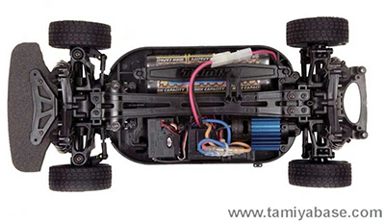
Figure 1 Tamiya Chassis
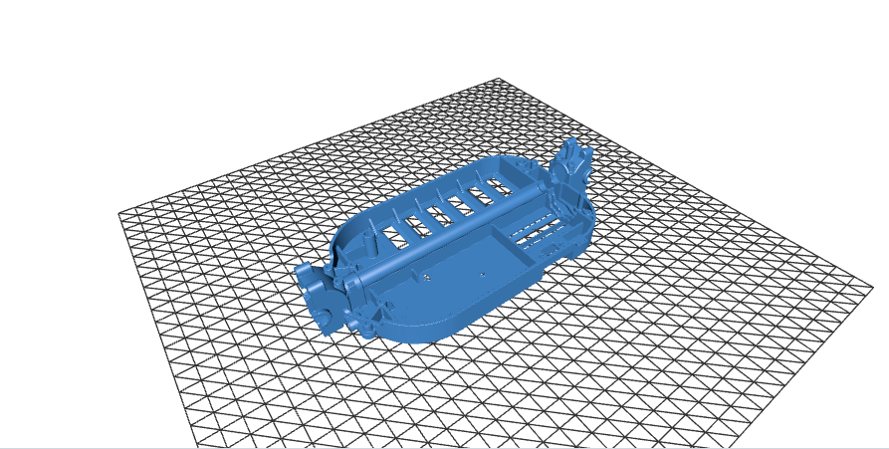
Figure 2 STL Chassis

Raspberry Pi 5:
A Raspberry Pi 5 is installed on the vehicle to coordinate the local execution of the system. Its main responsibilities are to capture the video stream, manage communication with the remote application, and process the control commands received from the client. This unit acts as the bridge between the software and the chassis.
The Raspberry Pi 5 was selected due the fact that high quality WebUSB cameras were a requirement, and other alternatives like an ESP32 were unavailable due to throughput limitations.
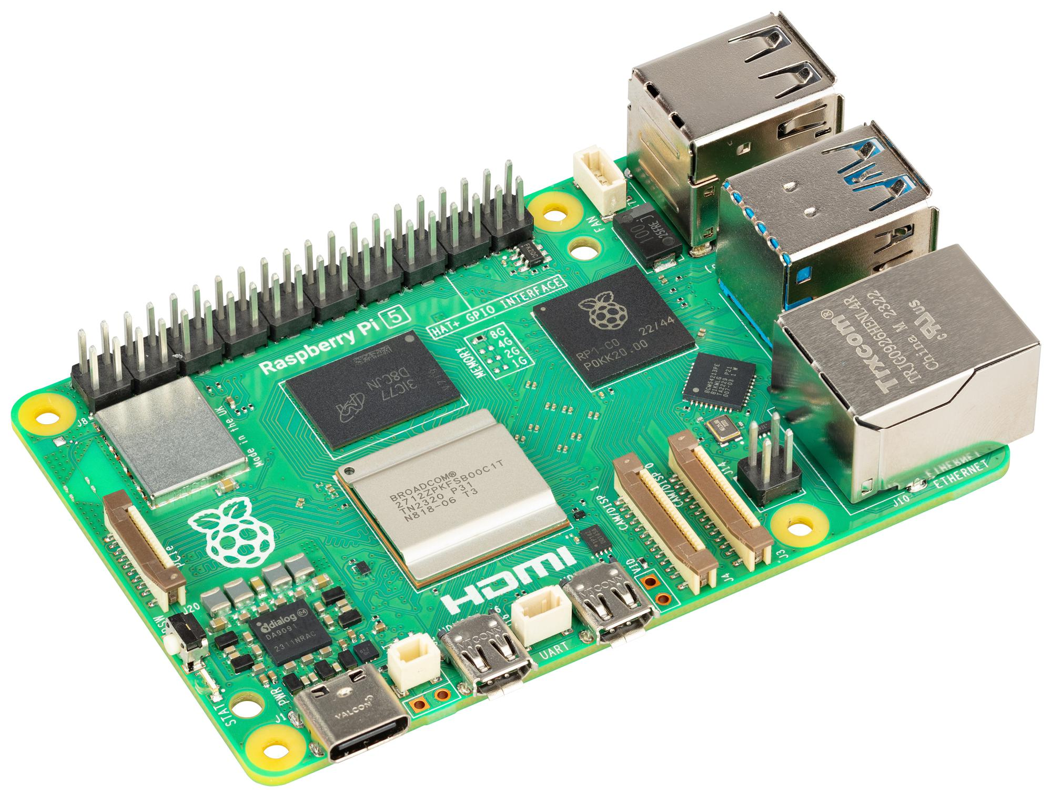
Figure 3 Raspberry Pi

Camera:
The camera is responsible for capturing the live video feed from the vehicle’s perspective. It is mounted on the chassis in a forward-facing position to provide the remote operator with a clear view of the driving environment. The placement of the camera is important because it directly affects usability, depth perception, and the operator’s ability to react to obstacles.
A Logitech HD Pro C920 was chosen because it had built in hardware encoding of the codecs that will be required for WebRTC, a USB interface, support for Linux Video stack, and good image quality.
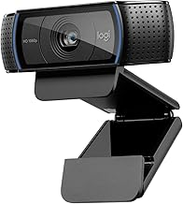
Figure 4 Logitech HD Pro C920

5G Connectivity Dongle:
The vehicle uses a 5G mobile connection to access the Internet outside a local Wi-Fi environment. This connection is essential for remote operation, as it provides the bandwidth required for video streaming and the low latency required for responsive control. The 5G device can be integrated as a modem, mobile router, or tethered connection, depending on the final implementation.
For this iteration a Huawei 4G dongle was used. From the point of view of the system, it’s just an internet connection. This is solely a price decision

Figure 5 Huawei 4G Dongle

Power Supply System:
For the power supply I will use the standard NiMH battery common on RC cars.
Also to adapt the voltage to the Raspberry Pi a small DC-DC voltage regulator is also attached and serves like the electrical interface between the battery, the Raspberry Pi, and the chassis.
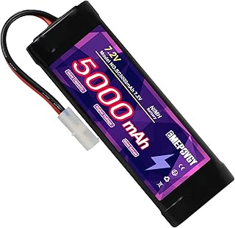
Figure 6 NiMH Battery

Design Considerations:
The hardware components were selected with the objective of building a functional proof of concept rather than a fully optimized commercial vehicle. For this reason, priority was given to components that were easy to integrate, configure, replace, and test. The main goal was to validate the complete system architecture: remote video transmission, 5G connectivity, browser-based interaction, and real-time vehicle control.
Each hardware element was chosen to reduce integration complexity. The use of an existing RC vehicle chassis avoids the need to design a mechanical platform from the beginning and provides a ready-to-use base with motor, steering, wheels, and suspension. This allows the development effort to focus on the communication and control layers of the project.
The Raspberry Pi was selected to act as a flexible bridge between the software system and the physical vehicle. Its role is not only to process the video stream and control commands, but also to simplify the connection between the different subsystems. By using a general-purpose computing platform, the system can be modified and tested more easily during development.
The camera was also selected with integration in mind. A simple camera interface reduces configuration effort and allows the video pipeline to be tested quickly. Since the project depends on real-time visual feedback, the camera does not need to represent the most advanced imaging solution available, but it must be reliable enough to validate the WebRTC streaming architecture.
The 5G connectivity device was included to demonstrate the feasibility of operating the vehicle outside a local network. In the context of this proof of concept, the important factor is not the specific modem or router model, but the ability to provide mobile Internet access with sufficient bandwidth and latency for video streaming and remote control.
Power distribution was considered from the perspective of stability and practicality. The additional electronic components must be powered without interfering with the original RC vehicle electronics. Therefore, the power system should be simple, accessible, and reliable enough to support repeated testing sessions.
Overall, the hardware design follows a modular philosophy. Each component has a clear responsibility and can be tested independently before being integrated into the complete system. This approach makes the prototype easier to assemble and debug, while also allowing future improvements such as a better camera, additional sensors, a more compact processing unit, or a more advanced control board.
As a result, the selected hardware provides a practical platform for validating the main idea of the project: that an RC vehicle can be remotely operated through a web interface using WebRTC video transmission and 5G connectivity. The emphasis is therefore placed on demonstrating the viability of the complete end-to-end system rather than on optimizing each individual hardware component.

General Architecture:
The complete system follows a distributed architecture composed of four main elements: the device, the application server, the TURN server, and the player. The device is the RC car and contains the onboard computing, video, communication, and actuation interfaces. The browser is the client-side application executed in the remote operator's web browser. The application server and TURN server provide the supporting infrastructure required to coordinate the session and establish the WebRTC connection across different networks.
The design separates coordination traffic from latency-sensitive real-time traffic. The application server handles device registration, session management, and WebRTC signaling. After negotiation, video and control data are exchanged between the RC car and the player through the route selected by Interactive Connectivity Establishment (ICE). A direct peer-to-peer route is preferred; the TURN server is used as a relay when the mobile network, carrier-grade NAT, or a firewall prevents direct connectivity. As a result, the application server is not required to process the media stream.
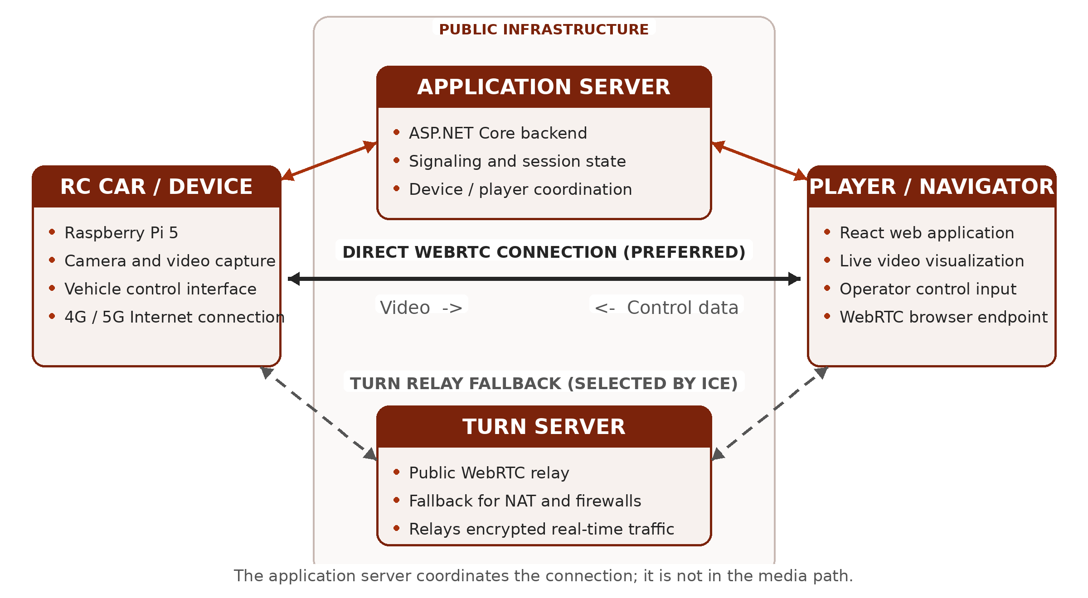

Architecture Components:

Device (RC Car):
The device is the physical endpoint installed on the vehicle. The Raspberry Pi 5 runs the local application, captures the stream from the forward-facing camera, creates the WebRTC peer connection, and interfaces with the motor and steering electronics. It reaches the Internet through the mobile connection and maintains a signaling connection with the application server so that it can announce its availability and receive session requests. During an active session, the device acts as the video producer and the consumer of the driving commands.

Application Server:
Implemented with ASP.NET Core, the application server provides the coordination layer. It keeps track of connected devices and players, creates and closes sessions, and forwards the WebRTC negotiation information exchanged by both endpoints, including session descriptions and ICE candidates. It also provides the point at which authentication and access rules can be applied. Once the peer connection is established, the server remains responsible for session state but is normally outside the video and control-data path.

TURN Server:
The TURN server is a separate, publicly reachable service whose purpose is to relay WebRTC traffic when a direct route is unavailable. This fallback is important for vehicles because mobile operators frequently place clients behind carrier-grade NAT. The endpoints first perform connectivity checks; if no direct candidate succeeds, ICE selects a relay candidate supplied by the TURN server. In that case, the encrypted video and control data pass through the relay, while the application server continues to handle signaling and session management.

Browser:
The player is the React application that opened in the remote operator's web browser. It displays the live camera stream, presents the state of the connection, and captures the operator's steering and throttle input. The browser creates the second WebRTC peer connection and sends the driving commands to the vehicle through a WebRTC data channel, while receiving the video track in the opposite direction. Because the player runs in a standard browser, the system does not require a dedicated desktop application.

End-to-End Communication Flow:
Device availability and discovery. When the onboard application starts, the RC car establishes Internet connectivity through the 5G modem and opens its signaling connection to the application server. It then registers itself as an available device. The server maintains the association between the device identifier and the active signaling connection, allowing the web application to discover that the car is online. At this stage, no video or control traffic is exchanged; the server is only maintaining presence and session state.
Session initiation. The operator opens the React application in the browser and requests a session with the selected vehicle. The application server validates the request according to the configured access rules, associates the player with the device, and notifies both endpoints that negotiation can begin. Keeping this step on the server prevents the two endpoints from needing to know each other's public network address in advance and provides a central place for authentication, authorization, and session lifecycle management.
WebRTC signaling. One endpoint creates an SDP offer describing the proposed WebRTC session, including the video track, supported codecs, transport parameters, and data channel. The application server forwards the offer to the other endpoint, which creates and returns an SDP answer. The server acts only as a trusted message broker during this exchange: it transports the descriptions required to configure the peer connections but does not receive or process the camera frames or driving commands.
ICE candidate exchange and path selection. In parallel with the SDP exchange, the device and player gather and exchange ICE candidates through the signaling channel. These candidates describe the network routes that may be used, such as local interfaces, publicly reachable addresses discovered through NAT traversal, and relay addresses allocated by the TURN server. ICE connectivity checks test the candidate pairs and select the highest-priority working route. A direct device-to-player path is preferred because it avoids an additional relay hop. If carrier-grade NAT on the mobile network, a firewall, or another restrictive network policy prevents direct connectivity, the endpoints use the TURN relay instead.
Secure transport establishment. After ICE has selected a viable route, WebRTC establishes its encrypted transports. The video stream is protected with SRTP using keys negotiated by DTLS, while control messages are carried by an SCTP data channel protected by DTLS. Consequently, the security properties of the real-time connection do not depend on whether traffic follows a direct route or passes through the TURN server; the relay forwards encrypted packets and does not terminate the WebRTC session.
Bidirectional real-time operation. During the active session, the Raspberry Pi captures and encodes frames from the onboard camera and sends the resulting video track to the player. The browser receives, decodes, and renders the stream for the operator. In the opposite direction, steering and throttle input collected by the user interface is serialized into compact control messages and transmitted over the WebRTC data channel. The device receives these messages and converts them into commands for the steering and motor interfaces. Media and control therefore share the negotiated WebRTC route but remain logically separate streams with different timing and reliability requirements.
Monitoring, recovery, and termination. The signaling connection remains active throughout the session so that the server can track participant state and communicate errors, renegotiation requests, or disconnection events. WebRTC monitors the selected transport and exposes connection statistics that can be used to observe latency, packet loss, jitter, and available bitrate. Temporary network variation is handled by the WebRTC congestion-control and buffering mechanisms; a longer route interruption may require a new ICE negotiation or termination of the session. When either participant disconnects, the server closes the logical session, the peer connections and media resources are released, and the device returns to the available state if its signaling connection remains active.
End-to-end paths and latency. The video path begins at camera capture on the vehicle and continues through encoding, 5G uplink transmission, the selected direct or relayed Internet route, browser decoding, and final display. The control path begins with operator input in the browser and continues through event processing, message serialization, WebRTC transmission, device-side parsing, and actuation. The application server is outside both latency-sensitive paths after negotiation, although the TURN server adds a network hop when relaying is required. This distinction is important for evaluation because measured end-to-end delay includes processing and presentation time as well as network propagation time.
Communication planes. The complete flow therefore consists of two logical planes. The coordination plane uses the application server for registration, discovery, signaling, and session management. The real-time plane uses the WebRTC connection for vehicle-to-player video and player-to-vehicle control, with the TURN server participating only when a direct route cannot be established. Separating these responsibilities reduces server bandwidth requirements and makes the prototype easier to test, maintain, scale, and extend.

WebRTC:
Web Real-Time Communication (WebRTC) is the real-time transport layer of the prototype. It combines a browser API with a suite of IETF protocols for exchanging media and generic application data between compatible endpoints. Its main advantage in this project is that the remote operator can receive video and, eventually, send vehicle data through a standard browser without installing a dedicated plug-in or media client. WebRTC also seeks the most direct available route between the peers, which makes it appropriate for an interactive system whose usefulness depends on low end-to-end delay (W3C, 2021; RFC 8825).

Purpose and Protocol Stack:
WebRTC is not a single protocol. At the application level, RTCPeerConnection represents the session and coordinates media tracks, data channels, connectivity checks, negotiation, and transport state. Underneath that API, media is carried as RTP and protected as SRTP, while non-media messages use SCTP data channels encapsulated in DTLS. ICE selects the route used by both kinds of traffic. This composition provides a common session abstraction while allowing video and control information to retain different delivery semantics.
The system contains two different types of WebRTC endpoint. The player is a WebRTC browser implemented with the native JavaScript API. The vehicle is a non-browser endpoint running on the Raspberry Pi and implemented in .NET with the SIPSorcery library. They interoperate through the same standardized offer/answer, ICE, DTLS, SRTP, RTP, and SCTP mechanisms. The result is a peer connection that carries a send-only video track from the vehicle to the browser and reserves bidirectional data channels for control, commands, telemetry, and events.

Connection Establishment and Signaling:
WebRTC deliberately leaves the signaling transport to the application. In this prototype, signaling is implemented with an ASP.NET Core SignalR hub. Both endpoints join a hub group identified by the device identifier. The group provides presence and rendezvous, while direct messages are addressed by SignalR connection identifier. The server forwards session descriptions and ICE candidates but does not parse video frames or vehicle messages. This keeps the coordination plane separate from the latency-sensitive real-time plane.
When a browser joins the group, the device receives a ClientJoined notification and creates a new RTCPeerConnection for that browser connection. The device adds its send-only H.264 track and the negotiated data channels, calls createOffer, and applies the generated offer as its local description. SignalR forwards the resulting Session Description Protocol (SDP) offer to the browser. The browser applies it as the remote description, creates an SDP answer, sets that answer locally, and returns it through the hub. The device then applies the answer as its remote description. This sequence follows the JSEP offer/answer model defined for WebRTC applications (RFC 8829).
The SDP exchange does not carry the video itself. It describes the proposed session, including media direction, codec and payload parameters, ICE credentials, DTLS fingerprints, and the SCTP data-channel association. ICE candidates are exchanged separately as they are discovered, a procedure commonly called trickle ICE. Because a candidate can arrive before the remote SDP description has been installed, both the browser and device queue early candidates and apply them only after the remote description is available. This ordering prevents the race between candidate discovery and offer/answer processing from invalidating an otherwise usable route.

ICE, STUN, and TURN:
Interactive Connectivity Establishment (ICE) addresses the fact that neither endpoint can assume it has a directly reachable address. Each peer gathers candidate transport addresses, forms candidate pairs, performs connectivity checks, and nominates a working pair. Host candidates represent local interfaces; server-reflexive candidates expose the public mapping learned through STUN; and relay candidates are allocations on a TURN server. ICE prioritizes the available pairs and normally selects a direct route when one succeeds (RFC 8445).
This mechanism is especially important on a mobile connection. The vehicle may be placed behind carrier-grade NAT, while the operator may be behind a second NAT or an enterprise firewall. STUN is sufficient when the discovered public mappings permit hole punching. If the two endpoints cannot communicate directly, TURN supplies a publicly reachable relay address and forwards the encrypted packets between them. Relay operation improves reachability but consumes server bandwidth and introduces an additional network hop, so it is treated as a fallback rather than the preferred route (RFC 8656).
The SignalR hub returns the same ICE-server configuration to the device and browser when they join. The Raspberry Pi maps this configuration to SIPSorcery's RTCIceServer objects, applies the credentials where required, and currently accepts at most ten ICE-server URLs. TURN/TLS URLs using the turns: scheme are not supported by the selected device path and are therefore skipped, while the browser can use the transports implemented by its WebRTC stack. Once connected, the player reads the selected candidate pair from getStats and reports the local and remote candidate types. This provides a simple way to distinguish a direct connection from a relayed one during testing.

Video Transport and H.264 Pipeline:
The current session is intentionally video-only. The Raspberry Pi advertises one send-only H.264 format with a 90 kHz RTP clock, dynamic payload type 96, packetization-mode=1, and constrained Baseline profile-level-id 42e01f. Packetization mode 1 permits non-interleaved RTP packetization, including fragmentation units for NAL units that exceed the network packet size, and is suited to low-delay interactive video. Constrained Baseline Level 3.1 is compatible with the configured 1280 x 720 at 30 frames per second operating point and with browser H.264 decoders (RFC 6184; RFC 7742).
Capture and WebRTC packetization are separated. FFmpeg opens the configured camera and produces an encoded H.264 RTP stream on an IPv6 loopback UDP socket. The device application receives those packets, filters the expected payload type, reconstructs each encoded access unit, and passes the complete frame to SIPSorcery. SIPSorcery then packetizes the access unit for each negotiated WebRTC peer. This design avoids decoding and re-encoding the video inside the .NET process, while keeping the browser-facing RTP session independent from the local FFmpeg transport.
Decoder initialization requires the H.264 sequence and picture parameter sets. The receive pipeline therefore caches SPS and PPS NAL units and prepends them to an IDR keyframe if the encoder did not include them in that access unit. RTP timestamps are also converted into frame durations using the 90 kHz clock, with the configured frame rate used as a fallback after startup, timestamp wraparound, or an encoder restart. These details are necessary for consistent browser decoding and presentation, even though they are not visible at the RTCPeerConnection API boundary.
Camera lifetime is tied to demand. A peer initially receives only an advertised track; the encoded source is attached when the connection reaches the connected state. FFmpeg starts for the first consumer, and the same encoded samples can be distributed to multiple active peer sessions without opening the camera once per viewer. When the last consumer disconnects, capture is stopped and the camera is released. In the browser, the ontrack callback assigns the received MediaStream to the HTML video element for immediate playback. Media transport follows the RTP and SRTP behavior defined for WebRTC (RFC 8834).

Data Channels and Delivery Semantics:
WebRTC data channels carry application messages over SCTP protected by DTLS. SCTP supports multiple logical streams and can provide ordered, unordered, reliable, or partially reliable delivery. These options are valuable for teleoperation because not all messages have the same meaning. A delayed steering update may be less useful than the latest update, while a discrete command or state-change event may need reliable, ordered delivery (RFC 8831).
The prototype creates four out-of-band negotiated channels with fixed identifiers at both endpoints. The control channel uses identifier 0 and the telemetry channel uses identifier 2; both are unordered and set maxRetransmits to zero. Lost samples are therefore not retransmitted, reducing the risk that obsolete state blocks newer information. The commands channel uses identifier 1 and the events channel uses identifier 3; both retain the default reliable, ordered behavior. Matching labels, identifiers, and options on the browser and device are mandatory because negotiated channels are not announced by the in-band Data Channel Establishment Protocol.
This channel split establishes an extensible application contract without mixing vehicle state, one-shot actions, acknowledgements, and telemetry in a single queue. In the current implementation, the channels are created and incoming payloads are decoded and logged, but the complete binding to motor control, command handling, telemetry production, and event processing remains future work. Consequently, the present WebRTC path fully demonstrates browser-compatible video transport and the data-channel topology, while the safety-critical control protocol still requires message validation, rate limits, timeout behavior, and an explicit fail-safe state.

Security Model:
WebRTC encrypts the real-time path by design. Media uses SRTP, with keys established through DTLS-SRTP, and data channels encapsulate SCTP inside DTLS. The DTLS fingerprint transported in SDP binds the negotiation to the certificate presented on the selected ICE path. The protection remains end to end between the WebRTC endpoints when TURN is used: the relay forwards encrypted packets and does not terminate the SRTP or data-channel security associations (RFC 8826).
Transport encryption does not replace application security. The SignalR signaling channel must use TLS and must authenticate and authorize both the operator and the device, because a party that can alter the SDP exchange can substitute fingerprints or redirect a session. Device identifiers must not be treated as access tokens. For a production deployment, TURN credentials should also be short-lived and issued dynamically rather than embedded in source code, and the application should enforce one authorized controller per vehicle, audit session creation, and reject malformed or stale control messages.

Lifecycle, Monitoring, and Recovery:
The device maintains one peer-session object per browser SignalR connection identifier. Each object owns its RTCPeerConnection, its pending ICE candidates, and the delegate that feeds encoded samples to that peer. Access to session state is synchronized because candidate callbacks, signaling messages, and connection-state notifications can arrive concurrently. Creating a replacement session closes the previous peer associated with the same client identifier and releases its media subscription.
Connection-state changes drive cleanup. When a peer becomes connected, the camera feed is attached. Failed, closed, or disconnected states remove the session, detach its video consumer, and close the peer connection. The device also keeps its SignalR membership alive with heartbeats and rejoins the device group after a signaling reconnection. An already established WebRTC stream can continue while SignalR reconnects because its media and data packets do not traverse the application server.
For evaluation, WebRTC statistics should be sampled throughout a run rather than only when the connection first becomes active. Relevant browser reports include the selected candidate type, round-trip time, packets sent and received, packet loss, jitter, frames decoded, frames dropped, and available bitrate. These measurements should be correlated with the use of a direct or relay candidate, the mobile access conditions, camera capture settings, and the observed glass-to-glass video delay. That separation makes it possible to determine whether a delay originates in capture and encoding, the network route, congestion control, decoding, or browser rendering.

Current Constraints:
The implemented video path offers only H.264 at a fixed capture operating point and does not include audio, simulcast, scalable video coding, or an application-level mechanism for changing the encoder bitrate and resolution in response to network conditions. WebRTC still provides transport feedback and congestion-control behavior, but the fixed external encoder limits how fully the sender can adapt. Future iterations can expose encoder controls and use the outbound RTP statistics to select a lower bitrate, frame rate, or resolution before queues and latency increase.
Connectivity is also constrained by the device-side transport support. The lack of TURN/TLS support can prevent a session on networks that permit only firewall-friendly TLS/TCP relay traffic, even though the browser supports additional TURN routes. A production system should provide a compatible relay path on common firewall-friendly ports, monitor relay allocation failures, and protect credentials. Mobile handovers and address changes should trigger an ICE restart or a controlled session rebuild; the current prototype closes failed peers but does not implement an explicit ICE-restart workflow.
Despite these limitations, the implementation validates the central design decision: a browser and a Raspberry Pi can negotiate a standards-based, encrypted, low-latency session across heterogeneous networks, using a direct path where possible and TURN where necessary. The separation between signaling, video, and typed data channels provides a practical foundation for completing the vehicle-control layer and for measuring how 5G access, NAT traversal, encoding, and browser playback contribute to end-to-end teleoperation performance.

Client:

Server:

Conclusions:

Future Work:

References:
Internet Engineering Task Force. RFC 6184: RTP Payload Format for H.264 Video. May 2011. https://www.rfc-editor.org/rfc/rfc6184.html
Internet Engineering Task Force. RFC 7742: WebRTC Video Processing and Codec Requirements. March 2016. https://www.rfc-editor.org/rfc/rfc7742.html
Internet Engineering Task Force. RFC 8445: Interactive Connectivity Establishment (ICE): A Protocol for Network Address Translator (NAT) Traversal. July 2018. https://www.rfc-editor.org/rfc/rfc8445.html
Internet Engineering Task Force. RFC 8656: Traversal Using Relays around NAT (TURN): Relay Extensions to Session Traversal Utilities for NAT (STUN). February 2020. https://www.rfc-editor.org/rfc/rfc8656.html
Internet Engineering Task Force. RFC 8825: Overview: Real-Time Protocols for Browser-Based Applications. January 2021. https://www.rfc-editor.org/rfc/rfc8825.html
Internet Engineering Task Force. RFC 8826: Security Considerations for WebRTC. January 2021. https://www.rfc-editor.org/rfc/rfc8826.html
Internet Engineering Task Force. RFC 8829: JavaScript Session Establishment Protocol (JSEP). January 2021. https://www.rfc-editor.org/rfc/rfc8829.html
Internet Engineering Task Force. RFC 8831: WebRTC Data Channels. January 2021. https://www.rfc-editor.org/rfc/rfc8831.html
Internet Engineering Task Force. RFC 8834: Media Transport and Use of RTP in WebRTC. January 2021. https://www.rfc-editor.org/rfc/rfc8834.html
World Wide Web Consortium. WebRTC 1.0: Real-Time Communication Between Browsers. W3C Recommendation, 26 January 2021. https://www.w3.org/TR/2021/REC-webrtc-20210126/

